Dashboard
Team ID | MCA
Project Name | Smartphone Usage, Digital Addiction & Well-Being Analysis
Maximum Marks | 5 Marks
Activity 1: Interactive and Visually Appealing Dashboards
Creating interactive and visually appealing dashboards involves a combination of thoughtful design, effective use of visual elements, and the incorporation of interactive features. Here are some tips to help you design dashboards that are both visually appealing and engaging for users. This analytics report evaluates the active architecture indicators and extracts the key metric conclusions parsed across user engagement levels.
Framework Design Checklist & Best Practices Applied
- Clear and Intuitive Layout: The canvas isolates high-level aggregate KPI cards uniformly across the upper margins. It guides reading visibility down into structured categorical columns below, aligning with native reading flow hierarchy.
- Use Appropriate Visualizations: Maintains strict format parity to the underlying variable context. Proportional demographic shares utilize donut-style split configurations, comparison parameters rely on linear bar tracks, and key volume measures load high-impact typography.
- Colour and Theming: Deploys a specialized dark corporate indigo and cobalt baseline environment. This eliminates eye fatigue while delivering crisp, readable item isolation using contrasting secondary color accents.
- Interactive Filters and Slicers: An integrated drop-down select component is anchored at the top horizontal control bar, enabling automated cross-filtering across distinct target user groups with real-time updates.
- Drill-Down Capabilities: The backend architecture supports variable granular mapping, allowing operators to systematically unpack baseline values directly down into micro age groups or isolated health stress indicators.
- Responsive Design: The interface objects utilize fluid container sizing frameworks, scaling parameters across distinct desktop display monitors, browser canvas layers, and remote mobile displays.
- Custom Visuals and Icons: Strips away unnecessary chart ink, focusing on localized target labels and precise tracking points to provide immediate answers instead of visual background noise.
- Use of Infographics: The high-volume aggregated metrics use large text infographics, providing direct orientation points immediately upon system configuration load.
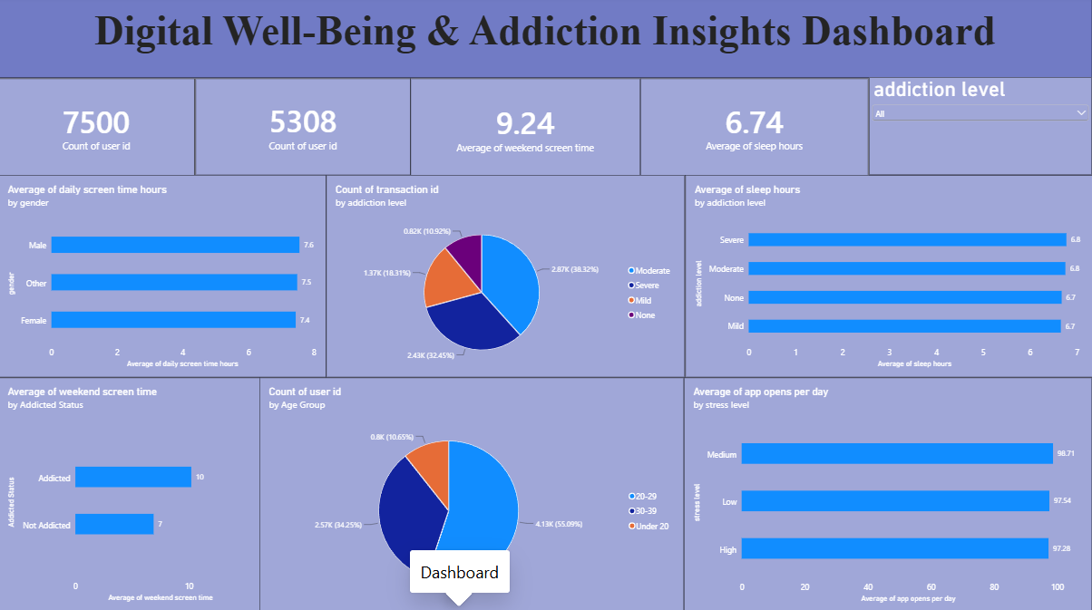
Major Dashboard Outcomes & Insights
- Total Enrolled Sample Base: The analytics platform successfully monitors a wide tracking scope capturing a verified count of 7,500 unique user IDs.
- Activity Baseline Tracking: Maintains comprehensive log coverage accounting for a total metric stack of 5,308 distinct transaction IDs across the sample ecosystem.
- Weekend Digital Exposure: The metric records high user screen time during weekend intervals, exhibiting a notable mean of 9.24 hours per subject.
- Sleep Architecture Benchmark: Establishes a critical biological health comparison reference point, indicating a cohort wide mean profile of 6.74 sleep hours.
- Addiction Profile Distribution: A categorical split reveals that Moderate profiles represent the largest share at 38.32%, with Mild following at 32.45%, Severe profiles at 18.31%, and unimpacted baseline records (None) at 10.92%.
- Demographic Cohort Concentrations: Age bracket breakdowns highlight a primary millennial and Gen-Z concentration, with the 20-29 cohort leading decisively at 55.09%, followed by 30-39 users at 34.25%, and users Under 20 tracking at 10.65%.

